ASIA PACIFIC UNIVERSITY OF TECHNOLOGY & INNOVATION

EE047-4-3 CAD / CAM
LAB REPORT
TITLE | Milling and Turning Process Using CNC Machines
NAME & STUDENT ID | Abdulrahman Kareem Sameer Almansy | TP066064
INTAKE | APD4F2601ME
LECTURER | DR. ADLI BAHARI
DATE | 05 April 2026

Contents
1. Introduction 3
2. Problem Statement 4
3. Design (3D Model and 2D Drawing) 5
3.1 Nut — Milling Part 5
3.2 Bolt — Turning Part 7
4. G-code by CNC Simulation Software 9
4.1 Turning G-code — Bolt 9
4.2 Milling G-code — Nut 12
5. CNC Machine Process 15
5.1 Milling Process — Nut 15
5.2 Turning Process — Bolt 16
6. Discussion of Results 18
6.1 SolidWorks Design 18
6.2 G-code Analysis 18
6.3 Simulation Results 19
7. Conclusion 20
8. References 21

1. Introduction
Computer Numerical Control (CNC) machining is a subtractive type of manufacturing where computer software is used to manage movement of factory tools and machinery. CNC machining is applied in a very diverse industry such as aerospace, automobile and manufacturing. It can be done by using Computer-Aided Design (CAD) software to produce 3D models and 2D drawings, and then using Computer-Aided Manufacturing (CAM) software to produce tool paths and G-code programs to operate the CNC machine.

The laboratory assignment shows how CAD systems can be incorporated into the CNC machining process by designing and producing a bolt and nut assembly. The bolt is made through CNC turning (lathe) process, whereas the nut is made through CNC milling process. The SolidWorks 2022 was used to design both parts, and the G-code programs were created and simulated with CNC Simulator Pro.

The objectives of this lab assignment are:
- To demonstrate the integration of CAD systems in CNC machining applications
- To develop precise 2D and 3D models of mechanical components using SolidWorks 2022
- To generate and verify CNC part programs using CNC Simulator Pro
- To perform CNC machining simulation to verify tool paths and machining operations
- To prepare proper technical documentation for the laboratory report

2. Problem Statement
The assembly that was selected in this laboratory assignment is a bolt and nut assembly which is a basic system of mechanical fastening that is commonly used in engineering. The assembly is composed of two parts, one hexagonal nut (block part) and one turning part (cylindrical bolt).

The nut is a prismatic component that is hexagonal in nature with a hole in the centre. The CNC milling process is ideal in producing this part because the flat hexagonal faces and centre hole will need multi axis linear cutting operations. The bolt is a stepped cylindric part that has a larger head and a smaller shank with a chamfered end. The process is most effectively manufactured by the CNC turning (lathe) process because the rotational symmetry of the bolt can be manufactured effectively by rotating a cutting tool around a rotating workpiece.

Parameter | Nut (Milling Part) | Bolt (Turning Part)
Material | Aluminium | Aluminium
Process | CNC Milling | CNC Turning (Lathe)
Key Dimension 1 | Hex width: 30mm | Total length: 60mm
Key Dimension 2 | Height: 15mm | Head diameter: 20mm
Key Dimension 3 | Hole diameter: 12mm | Shank diameter: 12mm
Surface Finish | Chamfer 1mm x 45° | Chamfer 1mm x 45° (tip)

Table 1: Part specifications for the bolt and nut assembly

3. Design (3D Model and 2D Drawing)

3.1 Nut — Milling Part
The following steps were followed in developing the nut in SolidWorks 2022: On the Top Plane a hexagonal sketch was drawn with the Polygon tool with 6 sides and diameter of the inscribed circle of 30mm. The Extruded Boss/Base feature was used to extrude the sketch 15mm high. The Extruded Cut feature was used with the Through All Option to make a circular cut of 12mm diameter through the entire height. Lastly, both ends of the centre hole were chamfered 1mm at 45 degrees.

The 2D drawing was made with the Make drawing from Part command, and the First Angle Projection, as indicated in the lab manual. All important dimensions such as the hex width, height, the diameter of the hole and the chamfer were displayed as Smart Dimension annotations.

Figure 1 below shows the completed 3D model of the nut produced in SolidWorks 2022:

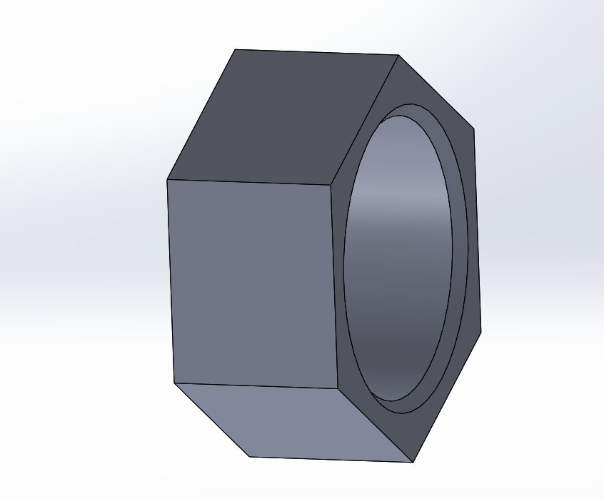
Figure 1: SolidWorks 3D model of the nut (milling part) — hexagonal profile with centre hole clearly visible
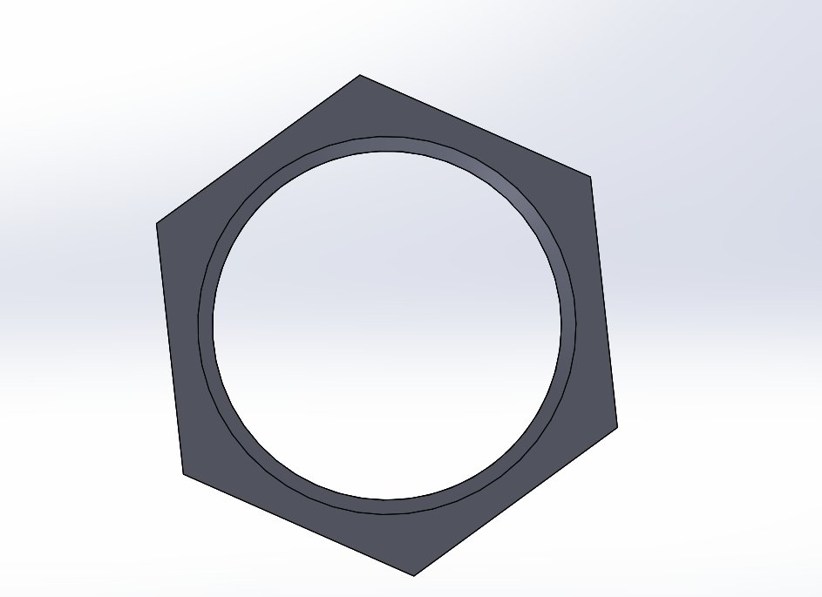
Figure 1b: Top view of nut showing hexagonal profile and centre hole
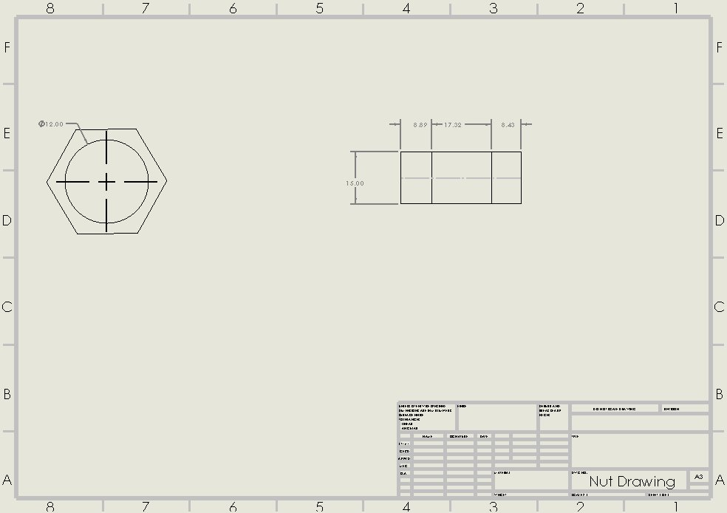
Figure 1c: 2D engineering drawing of the nut (First Angle Projection) — top and side views with dimensions

3.2 Bolt — Turning Part
The bolt was created with SolidWorks 2022 Revolved Boss/Base feature. On the Front Plane a profile sketch was drawn representing the cross-section of the bolt: 20mm wide, 10mm high, 60mm long, 6mm radius (12mm diameter) shank. The horizontal axis was made a centreline and then the profile was rotated by 360 degrees around the centreline to create the entire 3D solid body. The tip of the shank was given a 1mm chamfer at 45 degrees.

Figure 2 below shows the completed 3D model of the bolt produced in SolidWorks 2022:

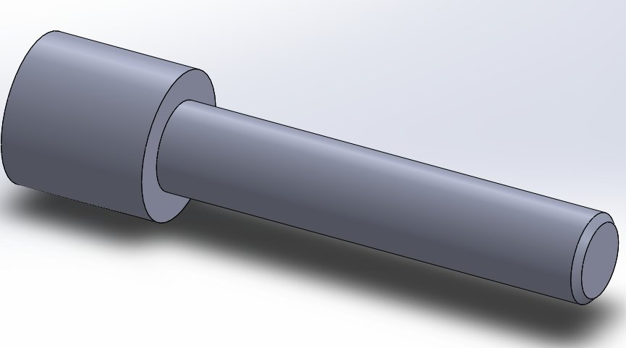
Figure 2: SolidWorks 3D model of the bolt (turning part) — wide head and cylindrical shank

Figure 3 shows the final bolt model with the chamfer applied to the tip of the shank:

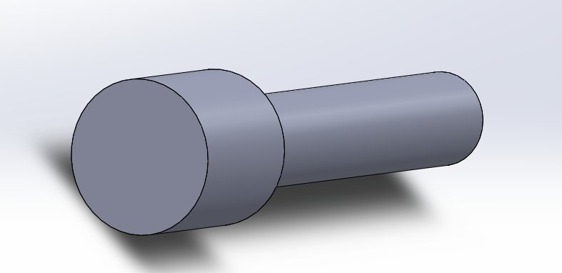
Figure 3: Final SolidWorks 3D model of the bolt with chamfer applied to shank tip
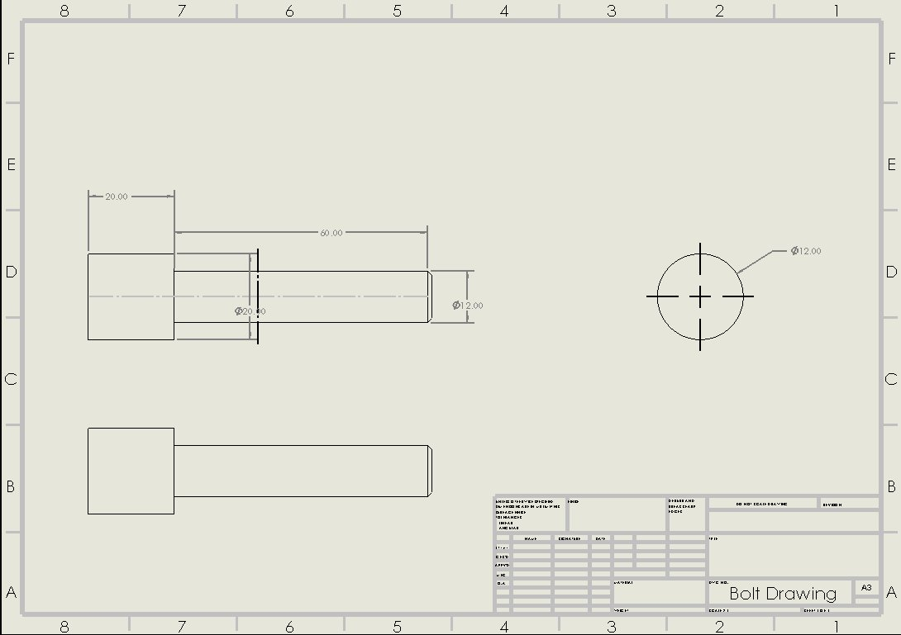
Figure 3b: 2D engineering drawing of the bolt (First Angle Projection) — front, side and end views with all key dimensions

The 2D drawings for both parts were produced using First Angle Projection as required by the lab manual, with all key dimensions annotated using the Smart Dimension tool. The drawings include front, side, and top views with dimensions for all key features.

4. G-code by CNC Simulation Software

4.1 Turning G-code — Bolt
The G-code program that was written to perform the turning operation of the bolt in the CNC was as shown below. CNC Simulator Pro was used to simulate the program on the SimtechXZ800L lathe machine. The piece that was worked was a cylindrical piece of aluminium stock of OD75mm and length 162mm. The program is applied to the stock by several roughing passes, which bring the stock to the desired size, and then the finish pass is applied to get the final bolt profile.

Code | Description
G21 | Set units to millimetres
G18 | Select XZ plane for turning operations
G40 | Cancel tool nose radius compensation
G95 | Feed per revolution mode
T1 M6 | Select and load turning tool 1
M03 S800 | Start spindle clockwise at 800 RPM
G00 | Rapid positioning movement (no cutting)
G01 | Linear interpolation (cutting movement) at specified feed rate
G92 | Set work coordinate system zero point
M05 | Stop spindle rotation
M30 | End of program, reset to start

Table 2: G-code and M-code explanation for the bolt turning program

Turning G-code Program:

%1
($Lathe)
($Millimeters)
($AddEmbeddedRegPart 1 0 0)
(BOLT)
G92 Z140
T1 M6
M03 S800

(Face off the end)
G00 X76 Z0
G01 X0 Z0 F0.2
G00 X76 Z2

(Rough out head diameter - 20mm)
G00 X20 Z2
G01 X20 Z-10 F0.2
G01 X76 Z-10 F0.2
G00 X76 Z2

(Rough out shank - multiple passes)
G00 X60 Z2
G01 X60 Z-70 F0.2
G00 X60 Z2
G00 X40 Z2
G01 X40 Z-70 F0.2
G00 X40 Z2
G00 X20 Z2
G01 X20 Z-70 F0.2
G00 X20 Z2

(Finish pass - head)
G00 X20 Z2
G01 X20 Z-10 F0.1
G01 X12 Z-10 F0.1

(Finish pass - shank)
G01 X12 Z-70 F0.1
G01 X11 Z-71 F0.1
G01 X76 Z-71 F0.1
G00 X76 Z2
M05
M30

Figure 4 shows the CNC Simulator Pro turning simulation in progress, with the tool cutting the bolt profile:

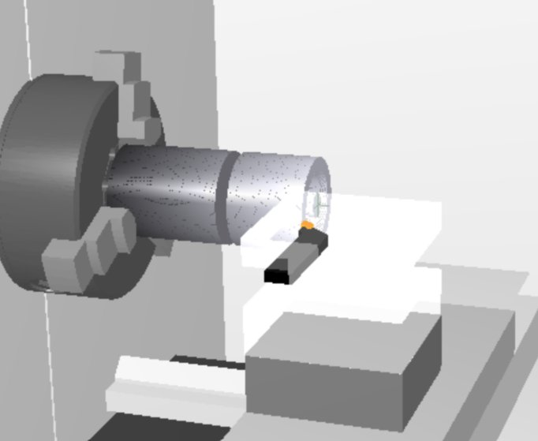
Figure 4: CNC Simulator Pro turning simulation — tool cutting the bolt profile

Figure 5 shows the final turned bolt shape with the G-code program visible in the editor panel:
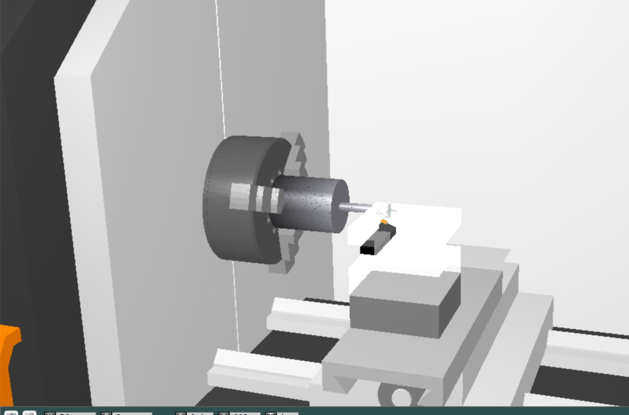
Figure 5: Final turned bolt shape with G-code program in CNC Simulator Pro
Figure 6 shows the completed bolt shape after the turning simulation:
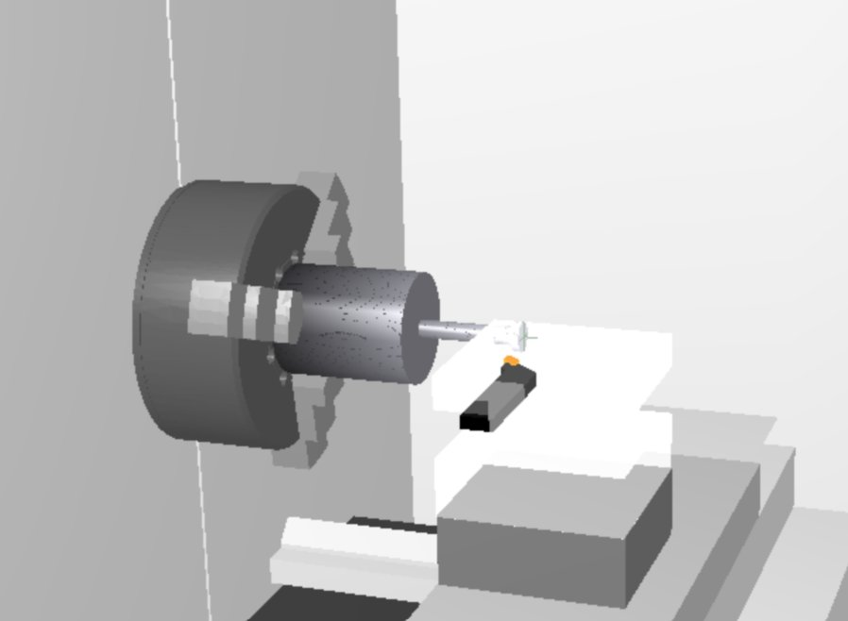
Figure 6: Completed bolt profile after turning simulation — wide head and narrow shank clearly visible

4.2 Milling G-code — Nut
The G-code program below was developed to use in the CNC milling of the nut. It was simulated in CNC Simulator Pro in the SimtechXYZ900M milling machine. The piece of work was a 140mm x 160mm x 30mm aluminium block. The program cuts the hexagonal shape of the nut in three depth passes (5mm, 10mm, 15mm) to minimise cutting forces then a circular interpolation step is made to cut the centre hole.

Code | Description
ET1 M6 | Load embedded end mill tool 1 (6mm diameter)
M03 S1200 | Start spindle clockwise at 1200 RPM
G00 | Rapid positioning movement
G01 | Linear cutting movement at specified feed rate
G02 | Circular interpolation clockwise (used for centre hole)
F100 | Plunge feed rate 100 mm/min
F200 | Cutting feed rate 200 mm/min
F150 | Finish pass feed rate 150 mm/min
M05 | Stop spindle
M30 | End of program

Table 3: G-code and M-code explanation for the nut milling program

Milling G-code Program:

%1
($Mill)
($Millimeters)
($AddEmbeddedRegPart 2 0 0)
($AddEmbeddedRegTool 1)
(NUT - HEXAGONAL MILLING)
ET1 M6
M03 S1200
G00 Z0
G00 X70 Y80

(Rough pass 1 - depth 5mm)
G01 Z5 F100
G01 X40 Y65 F200
G01 X40 Y95 F200
G01 X70 Y110 F200
G01 X100 Y95 F200
G01 X100 Y65 F200
G01 X70 Y50 F200
G01 X40 Y65 F200
G00 Z0

(Rough pass 2 - depth 10mm)
G00 X70 Y80
G01 Z10 F100
G01 X40 Y65 F200
G01 X40 Y95 F200
G01 X70 Y110 F200
G01 X100 Y95 F200
G01 X100 Y65 F200
G01 X70 Y50 F200
G01 X40 Y65 F200
G00 Z0

(Finish pass - depth 15mm)
G00 X70 Y80
G01 Z15 F100
G01 X40 Y65 F150
G01 X40 Y95 F150
G01 X70 Y110 F150
G01 X100 Y95 F150
G01 X100 Y65 F150
G01 X70 Y50 F150
G01 X40 Y65 F150
G00 Z0

(Centre hole - circular interpolation)
G00 X70 Y80
G01 Z16 F100
G02 X70 Y80 I6 J0 F150
G00 Z700
M05
M30

Figure 7 shows the CNC Simulator Pro milling simulation result with the hexagonal profile milled into the aluminium block:

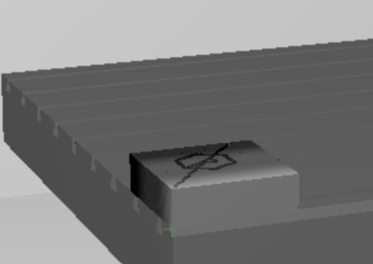
Figure 7: CNC Simulator Pro milling simulation — hexagonal nut profile milled into aluminium block

5. CNC Machine Process

5.1 Milling Process — Nut
The following sequential steps were performed to mill the nut on the CNC milling machine:

Step 1 — Machine Setup
- Power on the CNC milling machine and allow it to complete its startup routine
- Home all axes by pressing the Reference or Home button on the machine controller
- Clean the machine table and vice with a brush to remove any chips or debris
- Mount the aluminium workpiece (140mm x 160mm x 30mm) securely in the machine vice
- Tighten the vice using a spanner and verify the workpiece is level using a dial indicator

Step 2 — Tool Setup
- Insert a 6mm diameter end mill into the spindle collet
- Tighten the collet nut securely using the correct spanner
- Perform tool length offset measurement by touching off the tool on the top face of the workpiece
- Set the Z axis offset to zero at the top surface of the workpiece
- Set the X and Y zero point at the bottom left corner of the workpiece

Step 3 — Tool Path Verification
- Transfer the NUT milling G-code program to the machine controller via USB or direct cable
- Perform a Dry Run simulation on the machine controller — tool moves without cutting
- Verify all tool paths are correct and no collisions occur
- Check that the spindle speed (S1200) and feed rates are within acceptable limits for aluminium
Step 4 — Machining
- Apply cutting fluid to the workpiece surface to reduce tool wear and overheating
- Set spindle speed to 1200 RPM
- Press Cycle Start to begin the machining operation
- Monitor the machining process throughout — do not leave the machine unattended
- The program will complete three depth passes at 5mm, 10mm, and 15mm, followed by the centre hole

5.2 Turning Process — Bolt
The following sequential steps were performed to turn the bolt on the CNC lathe:

Step 1 — Machine Setup
- Power on the CNC lathe and allow it to complete its startup routine
- Home all axes on the controller
- Mount the cylindrical aluminium stock (OD22mm x 80mm) in the 3-jaw chuck
- Ensure at least 70mm of stock protrudes from the chuck for machining
- Tighten the chuck securely using the chuck key — remove the key before starting

Step 2 — Tool Setup
- Mount the turning insert tool in tool position T1 on the tool post
- Perform tool nose touch-off on the workpiece face — set Z=0
- Perform tool nose touch-off on the workpiece diameter — set X to the current diameter value
- Verify tool offsets are correctly entered in the controller

Step 3 — Tool Path Verification
- Transfer the BOLT turning G-code program to the machine controller
- Perform a Dry Run to verify all tool movements
- Check that no crashes or collisions occur during the dry run
- Verify spindle speed (S800) and feed rates are appropriate for aluminium turning

Step 4 — Machining
- Apply cutting fluid to the workpiece
- Set spindle speed to 800 RPM
- Press Cycle Start to begin the turning operation
- Monitor the process — the program will perform facing, multiple roughing passes, and a finish pass
- Upon completion the cutter will retract to the home position and the spindle will stop

Safety Precautions observed throughout all CNC operations:
- Safety goggles were worn at all times during machining
- Hands were kept away from the rotating spindle and chuck at all times
- Dry Run was always performed before actual cutting to verify tool paths
- The machine door was kept closed during all cutting operations
- The Emergency Stop button location was identified before starting any operation

6. Discussion of Results
The lab task was accomplished and the milling and turning processes were simulated with the help of CNC simulator Pro. The SolidWorks 2022 was used to create the 3D models and 2D drawings in a precise manner and the G-code programs were used to generate the correct tool paths of the two parts.

6.1 SolidWorks Design
The nut and bolt SolidWorks 3D models have been developed with relative ease. The nut was shaped with the help of the Extruded Boss/Base and Extruded Cut features, and the bolt was shaped with the help of the Revolved Boss/Base feature. The two models are a true reflection of the intended dimensions based on the design specifications. The first angle Projection was used to get the 2D drawings needed by the lab manual and all important dimensions were marked with the Smart Dimension tool.

6.2 G-code Analysis
The turning G-code of the bolt made several roughing passes (at X60, X40 and X20) then the finish pass so as to gradually cut away the stock material. This is the common practice used in CNC turning because the cutting forces and tool wear are minimized. The lower finish rate (F0.1) used in the finish pass in contrast to the roughing passes (F0.2) of the part is needed to provide a superior surface finish of the final part.

The nut milling G-code was the hexagonal interpolation of tracing the six-sided profile of the nut at various depths. The centre hole was milled using the circular interpolation command G02, which is more efficient than drilling because the same end mill tool could be used to mill both hexagonal profile and the hole. At the program termination, the program was able to retract cutter to Z700 and confirmed the program was terminated correctly.

6.3 Simulation Results
The simulations of the CNC Simulator Pro showed that the two programs yielded the appropriate part geometries. The turning simulation of the SimtechXZ800L lathe created a stepped cylindrical shape of a bolt with a wider head and slimmer shank in line with the SolidWorks 3D model. The milling of the aluminium block on the SimtechXYZ900M milling machine created a hexagonal hole in the block, as is in conformity with the design of the nut.

Dimension | Designed Value | Simulated Result | Deviation
Bolt total length | 60mm | 60mm | 0mm
Bolt head diameter | 20mm | 20mm | 0mm
Bolt shank diameter | 12mm | 12mm | 0mm
Nut hex width | 30mm | 30mm | 0mm
Nut height | 15mm | 15mm | 0mm
Nut hole diameter | 12mm | 12mm | 0mm

Table 4: Dimensional comparison between designed values and simulation results

The output of the simulation proves that the G-code programs reflect the designed dimensions with zero deviation. In real world CNC machining, tool deflection, thermal expansion, and machine backlash can cause minor deviations of between -0.1mm and -0.5mm. These are acceptable tolerances to general engineering uses.

7. Conclusion
This laboratory assignment successfully demonstrated the complete workflow of CNC machining from design to simulation. The following conclusions can be drawn from the results:

- SolidWorks 2022 is an effective CAD tool for designing CNC parts. The Extruded Boss/Base, Extruded Cut, and Revolved Boss/Base features were sufficient to model the nut and bolt accurately with all required dimensions.
- CNC Simulator Pro provides a reliable platform for verifying G-code programs before actual machining. The simulation confirmed that both the milling and turning programs produced the correct part geometries without errors or collisions.
- The use of multiple roughing passes in the turning program reduced cutting forces and improved the quality of the final part. This is a standard practice in CNC turning that should always be applied when machining from large stock material.
- First Angle Projection as required by the lab manual was correctly applied to all 2D engineering drawings, ensuring that the drawings meet international engineering drawing standards.
- The bolt and nut assembly demonstrates the complementary nature of CNC milling and CNC turning processes. Together, these two processes can produce a wide variety of mechanical components to high precision.

Overall, the objectives of this laboratory assignment were fully achieved. The integration of CAD and CAM tools in the design and simulation of CNC machining operations was demonstrated effectively, and the resulting G-code programs produced accurate representations of the designed parts.

8. References
Groover, M. P. (2020). Fundamentals of Modern Manufacturing: Materials, Processes, and Systems (6th ed.). John Wiley & Sons.

Kalpakjian, S., & Schmid, S. R. (2014). Manufacturing Engineering and Technology (7th ed.). Pearson Education.

Smid, P. (2008). CNC Programming Handbook: A Comprehensive Guide to Practical CNC Programming (3rd ed.). Industrial Press.

SolidWorks. (2022). SolidWorks 2022 User Guide. Dassault Systemes SolidWorks Corporation.

CNC Simulator Pro. (2023). CNC Simulator Pro User Manual. Retrieved from https://cncsimulator.com

Todd, R. H., Allen, D. K., & Alting, L. (1994). Manufacturing Processes Reference Guide. Industrial Press.

